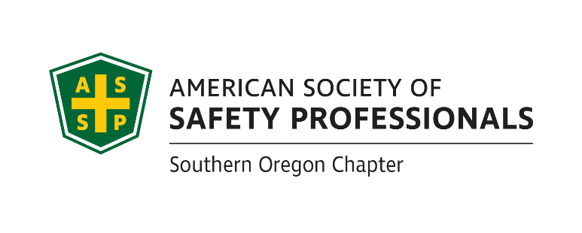

**ASSP Award Nomination Form**

**2024 SOUTHERN OREGON**

**OCCUPATIONAL SAFETY & HEALTH CONFERENCE**

***Community Member Who Gets It Award .***

Section 1 Submitter Information

Please share information about yourself, how you know the community member being nominated:

|  |  |  |  |  |
| --- | --- | --- | --- | --- |
| Company |  | Name | |  |
| Address |  | Relation to Community Member Nominated | |  |
| Phone |  | Your Title | |  |
| Email |  | | Fax |  |

Section 2 Nominee Information

Please provide information about the community member that you are nominating for this award:

|  |  |  |  |
| --- | --- | --- | --- |
| Company |  | Name |  |
| Address |  | Job Title |  |
| Phone |  | County |  |
| Email |  | | |

**If you have questions or to arrange packet delivery:**

Roy Harper [roy.harper@bbsi.com](mailto:roy.harper@bbsi.com) (541) 200-2199

Michael Hill [michil@saif.com](mailto:michil@saif.com) (541) 857-4229

David Hanson [davhan@saif.com](mailto:davhan@saif.com) (541) 857-4236

**Send your packets to:**

ASSP – Southern Oregon Chapter

P.O. Box 1481

Medford, OR 97501-0110

**Deadline:** Applications must be received by **August 30, 2024** at SAIF, Medford Office at 990 N. Phoenix Rd. Ste. 101, Medford, OR 97504.

**Incomplete Applications will not be accepted**

***Continue Page 2 ***

***Community Member Who Gets It Award.***

Section 3 Application Checklist

Complete form Sections 1 & 2 by typing in each shaded field and printing

Type written summary below describing specific accomplishments or on separate page as needed

Attach any Supporting Documentation

**The Community Member Who Gets It Award** recognizes a community member who has demonstrated an outstanding commitment to safety and health. This nomination will show how this person has set the pace for safety in their community going above and beyond to keep others safe. This nomination should also explain how their efforts influenced other members in the community.

Written Summary (Or attach a separate page as needed):

|  |
| --- |
|  |

This award will be evaluated annually and presented on merit.

**If selected, a photo will be requested.**

*Awards Committee Notes:*________________________________________________________

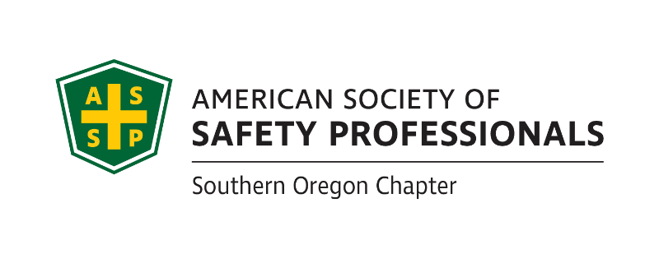_______________________________________________________________________________________________________________________________________________________________________________________________________________________________________

**If you have questions or to arrange packet delivery:**

Roy Harper [roy.harper@bbsi.com](mailto:roy.harper@bbsi.com) (541) 200-2199

Michael Hill [michil@saif.com](mailto:michil@saif.com) (541) 857-4229

David Hanson [davhan@saif.com](mailto:davhan@saif.com) (541) 857-4236

**Deadline:** Applications must be received by **August 30, 2024** at SAIF, Medford Office at 990 N. Phoenix Rd. Ste. 101, Medford, OR

**Incomplete Applications will not be accepted**

**Send your packets to:**

ASSP – Southern Oregon Chapter

P.O. Box 1481

Medford, OR 97501-0110