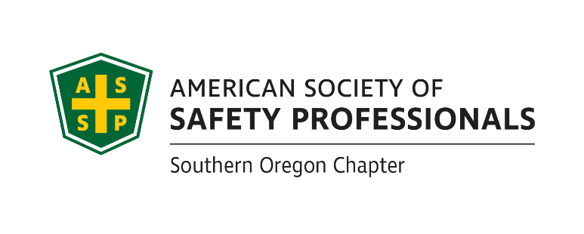

**ASSP Award Nomination Form**

**2022 SOUTHERN OREGON**

**OCCUPATIONAL SAFETY & HEALTH CONFERENCE**

***Business Leader Who Gets It Award .***

Section 1 Submitter Information

Please share information about yourself, how you know the business leader being nominated:

|  |  |  |  |  |
| --- | --- | --- | --- | --- |
| Company |  | Name | |  |
| Address |  | Relation to Business Leader Nominated | |  |
| Phone |  | Your Title | |  |
| Email |  | | Fax |  |

Section 2 Nominee Information

Please provide information about the business leader that you are nominating for this award:

|  |  |  |  |
| --- | --- | --- | --- |
| Company |  | Name |  |
| Address |  | Job Title |  |
| Phone |  | Areas of Responsibility  Within Company |  |
| Email |  | | |

**If you have questions or to arrange packet delivery:**

David Hanson [davhan@saif.com](mailto:davhan@saif.com) (541)-857-4236 or

Shyra Vaughn [shyvau@saif.com](mailto:shyvau@saif.com) (541)-857-9692

**Send your packets to:**

ASSP – Southern Oregon Chapter

P.O. Box 1481

Medford, OR 97501-0110

**Deadline:** Applications must be received by **August 26, 2022** at SAIF, Medford Office at 990 N. Phoenix Rd. Ste. 101, Medford, OR 97504.

**Incomplete Applications will not be accepted**

***Continue Page 2 ***

***Business Leader Who Gets It Award.***

Section 3 Application Checklist

Complete form Sections 1 & 2 by typing in each shaded field and printing

Type written summary below describing specific accomplishments or on separate page as needed

Attach any Supporting Documentation

**The Business Leader Who Get’s It Award** recognizes a business leader who has demonstrated an outstanding commitment to safety and health. This nomination will show how this leader has set the pace for safety in their organization going above and beyond the minimum requirements based on a core value to keep employees safe. This nomination should also explain the fruit of their efforts based on reduced injury rates, hazard elimination, and cultural elements that prove that the organization has benefitted from this leader’s efforts.

Written Summary (Or attach a separate page as needed):

|  |
| --- |
|  |

**Persons eligible for this award may not be a full time safety professional and must have a leadership role in their organization such as Principal, Manager, Controller, CEO, CFO, President or Owner:**

This award will be evaluated annually and presented on merit.

**If selected, a photo will be requested.**

*Awards Committee Notes:*________________________________________________________

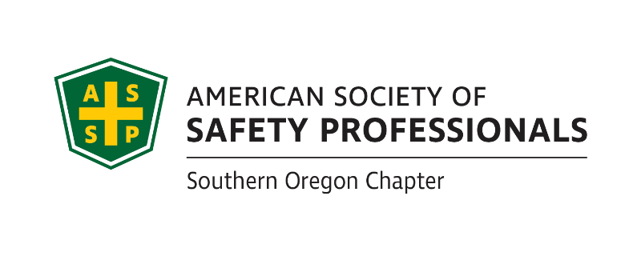_______________________________________________________________________________________________________________________________________________________________________________________________________________________________________

**Deadline:** Applications must be received by **August 26, 2022** at SAIF, Medford Office at 990 N. Phoenix Rd. Ste. 101, Medford, OR

**Incomplete Applications will not be accepted**

**If you have questions or to arrange packet delivery:**

David Hanson [davhan@saif.com](mailto:davhan@saif.com) (541)-857-4236 or

Shyra Vaughn [shyvau@saif.com](mailto:shyvau@saif.com) (541)-857-9692

**Send your packets to:**

ASSP – Southern Oregon Chapter

P.O. Box 1481

Medford, OR 97501-0110