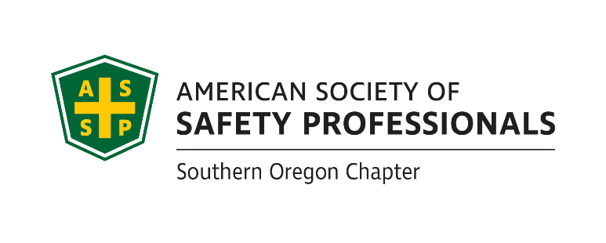

**2021 SOUTHERN OREGON**

**OCCUPATIONAL SAFETY & HEALTH CONFERENCE**

ASSP Award Application

***Best of the Best Safety Committee Award*** *_*

Section 1 Company Information

|  |  |  |  |  |
| --- | --- | --- | --- | --- |
| Company |  | Contact Person | |  |
| Division |  | Number of Employees | |  |
| Address |  | North American Industrial Classification System Code | |  |
| Phone |  | To Look Up NAICS Code: <https://www.naics.com/search/> | | |
| Email |  | | Fax |  |

Section 2 Injury and Illness Statistics

Provide Injury and Illness statistics for each year:

|  |  |  |  |
| --- | --- | --- | --- |
| Year | Total Number of Recordable | Number of regular and | Incident Rate: |
| Injuries & Illnesses on OSHA | overtime hours for all | Equals Number Recordable Injuries |
| 300 A Summary | employees for the year | Times 200,000 / Exposure hours |
| **2020** |  |  |  |
| **2019** |  |  |  |
| **2018** |  |  |  |

Section 3 Application Checklist

Complete form Sections 1 & 2 by typing in each shaded field and printing

Attach 2-page type written summary describing specific accomplishments

Attach a list of current safety committee members

Attach copies of safety committee minutes if applicable from past 12 months

Attach quarterly inspection findings for this same period

Attach any other supporting documentation that supports your achievement

**Deadline:** Applications must be received by **August 27, 2021**

Mail to SAIF: 990 N. Phoenix Rd. Ste. 101, Medford, OR 97504

(Questions: David Hanson [davhan@saif.com](mailto:davhan@saif.com) 541.857.4236)

**Incomplete Applications will not be accepted**

Pg. 1

***Best of the Best Safety Committee Award*** *_*

**Please submit a written summary** of not more than two (2) type written pages of safety committee accomplishments, and also include all items listed on first page of this application.

One Best of the Best Safety Committee Award winner will be selected by the awards committee that demonstrates a superior safety committee effort during the award period. The Best of the Best Award will be given to the committee who outshines the rest in preventing harm to workers, promoting the cause of safety and health and making safety fun and engaging for all employees.

**If selected, a photo will be requested. Incomplete applications will not be accepted!**

*Awards Committee Notes:*________________________________________________________

****_____________________________________________________________________________________________________________________________________________________________________________________________________________________________________________________________________________________________________________________________________________________________________________________________________________________________________________________________________________________________________________________________________________________________________________________________________________________________________________________________________________________________________________________

**Deadline:** Applications must be received by **August 27, 2021.** Mail to SAIF: 990 N. Phoenix Rd. Ste. 101, Medford, OR

**Incomplete Applications will not be accepted**

**SAIF Offices are not open for drop-offs**

**Call to arrange delivery**

**If you have questions or to arrange packet delivery:**

David Hanson [davhan@saif.com](mailto:davhan@saif.com) (541)-857-4236

Pg. 2