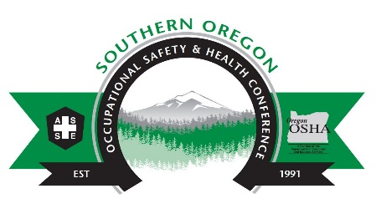
Show your support for Occupational Safety and Health in 2019!!
PLATINUM LEVEL $2000 or more
- You Receive the Benefits of GOLD level, plus:
- 2 Complimentary 2-day Conference Registrations OR Complimentary Exhibit Booth
- Platinum Recognition Award plaque to be presented during Award Ceremony on 10/18/2019 (funds must be received by 09/15/2019).
- Room Sponsorship (funds must be received by 09/15/2019 to be considered for room sponsorship).
GOLD LEVEL $750 - $1999
- You Receive the Benefits of SILVER level, plus:
- Gold Recognition Award plaque to be presented during Award Ceremony on 10/18/2019 (funds must be received by 9/15/2019).
SILVER LEVEL $100 - $749
- ASSE home page Logo Placement in ad scroll
- Listing in Conference Program (funds and artwork must be received by 7/15/2019 to be listed in conference program).
- Verbal Recognition During Conference in General Sessions
- Company Logo in Sponsor Slide Show in Ballroom
SUSTAINING LEGACY Sponsorship 2015 – 2019 Sponsorship
- For continuous conference sponsorship spanning the five years beginning in 2015, continuing to and including 2019.
- Logo listed on sustaining legacy Banner
MIXER Sponsorship Wednesday Night $650+
- Table display and a few minutes to welcome attendees during the Social Mixer, on the evening of October 16th
Additional Information
For questions about sponsorship, please contact David Hanson, 541-857-4236 or DAVHAN@saif.com
- (Funds must by 10/10/2019)

A joint effort of the Southern Oregon Chapter of the American Society of Safety Professionals, and Oregon OSHA

