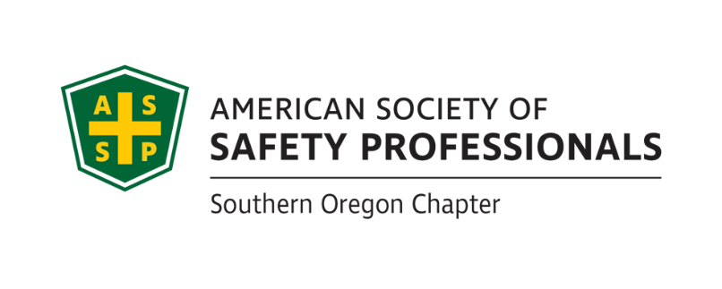

BCSP Study Group
Third Tuesdays at 4:30 – 5:30 pm
Next study group, December 19th

Free virtual (Microsoft Teams) study group for ASSP Members studying subject matter, study and test taking techniques that could be helpful while taking the OHST, SMS, ASP, CSP or other safety related certification exams.

Available for ASSP members. Please notify David Hanson about your interest and an invitation link will be emailed to you:

davhan@saif.com

