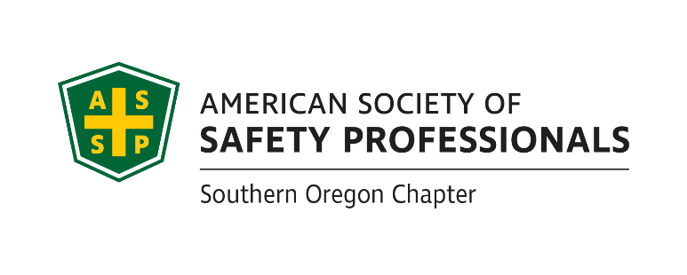
2019 SOUTHERN OREGON
OCCUPATIONAL SAFETY & HEALTH CONFERENCE
ASSP Award Application

Safety Committee Recognition Award In Honor of ~ Frank J. Bertak

Best of the Best Safety Committee Award _

Section 1 Company Information

Company |  | Contact Person
Division |  | Number of Employees
Address |  | North American Industrial Classification System Code
Phone |  | To Look Up NAICS Code: https://www.naics.com/search/
Email |  |  | Fax

Section 2 Injury and Illness Statistics
Provide Injury and Illness statistics for each year:

Year | Total Number of Recordable | Number of regular and | Incident Rate:
 | Injuries & Illnesses on OSHA | overtime hours for all | Equals Number Recordable Injuries
 | 300 A Summary | employees for the year | Times 200,000 / Exposure hours
2018
2017
2016

Section 3 Application Checklist

Complete form Sections 1 & 2 by typing in each shaded field and printing

Attach 1-page type written summary describing specific accomplishments

Attach Copy of a Safety committee agenda

Attach a list of current safety committee members

Attach copies of safety committee minutes from past 12 months (July 2018 through June 2019)
Attach quarterly inspection findings for this same period. (You must have at least one inspection for each quarter of the year.)
Deadline: Applications must be received by August 30, 2019
at SAIF-Medford Office at 990 N. Phoenix Rd. Ste. 101, Medford, OR 97504
(Questions: Michael Hill michil@saif.com 541.857.4229)
Incomplete Applications will not be accepted

Safety Committee Recognition Award

The Safety Committee Recognition Award identifies safety committees, its members and activities that have made a significant contribution towards the company’s overall success. Businesses of qualifying safety committees must not have experienced a fatality or catastrophic accident in the past twelve months prior to the award presentation.

Please submit a written summary of not more than one (1) type written page of safety committee accomplishments, and also include:

Example of the safety committee agenda
A list of current members
Copies of safety committee minutes from the past 12 months (July 1 to June 30)
Quarterly inspection findings from this same time period

Note: The safety committee minutes and inspection reports must meet the requirements of
OAR 437-001-0765 http://www.orosha.org/pdf/rules/division_1/437-001-0765.pdf

Best of the Best Safety Committee Award

One Safety Committee Recognition Award winner will be selected by the awards committee that demonstrates a superior safety committee effort during the award period. The Best of the Best Award will be given to the committee who outshines the rest in preventing harm to workers, promoting the cause of safety and health and making safety fun and engaging for all employees.

If selected, a photo will be requested. Incomplete applications will not be accepted!

Awards Committee Notes:________________________________________________________
_____________________________________________________________________________________________________________________________________________________________________________________________________________________________________________________________________________________________________________________________________________________________________________________________________________________________________________________________________________________________________________________________________________________________________________________________________________________________________________________________________________________________________________________
If you have questions or to arrange packet delivery:
Michael Hill michil@saif.com (541) 857-4229 or David Hanson davhan@saif.com (541)-857-4236

Deadline: Applications must be received by August 30, 2019 at SAIF, Medford Office at 990 N. Phoenix Rd. Ste. 101, Medford, OR

Incomplete Applications will not be accepted

