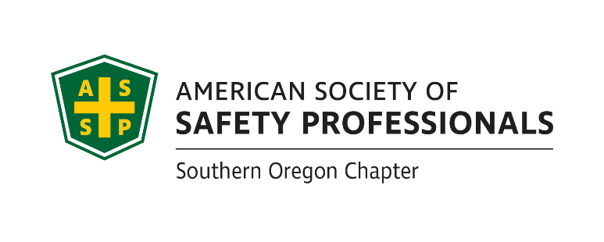
ASSP Award Nomination Form
2019 SOUTHERN OREGON
OCCUPATIONAL SAFETY & HEALTH CONFERENCE

Safety Committee Champion Award .

Section 1 Submitter Information
Please share information about yourself, how you know the safety committee member being nominated:
Company |  | Name
Address |  | Relation to Business Leader Nominated
Phone |  | Your Title
Email |  |  | Fax

Section 2 Nominee Information
Please provide information about the safety committee member that you are nominating for this award:

Company |  | Name
Address |  | Job Title
Role on the Committee |  | Areas of Responsibility  Within Company
Email

If you have questions or to arrange packet delivery:

Michael Hill michil@saif.com (541) 857-4229
David Hanson davhan@saif.com (541)-857-4236
Send your packets to:

ASSP – Southern Oregon Chapter
P.O. Box 1481
Medford, OR 97501-0110

Deadline: Applications must be received by August 30, 2019 at SAIF, Medford Office at 990 N. Phoenix Rd. Ste. 101, Medford, OR 97504.

Incomplete Applications will not be accepted

Continue Page 2
Safety Committee Champion Award.

Section 3 Application Checklist

Complete form Sections 1 & 2 by typing in each shaded field and printing

Type written summary below describing specific accomplishments or on separate page as needed

Attach any Supporting Documentation

The Safety Committee Champion Award recognizes a safety committee member who has demonstrated an outstanding commitment to safety and health. This nomination will show how this cooperative member is a true champion for safety in their organization going above and beyond the minimum requirements based on a caring to keep coworkers safe. This nomination should explain the specific work performed and accomplishments this champion has realized.

Written Summary (Or attach a separate page as needed):

Persons eligible for this award may not be a senior manager or executive in the organization.

This award will be evaluated annually and presented on merit.

If selected, a photo will be requested.

Awards Committee Notes:________________________________________________________
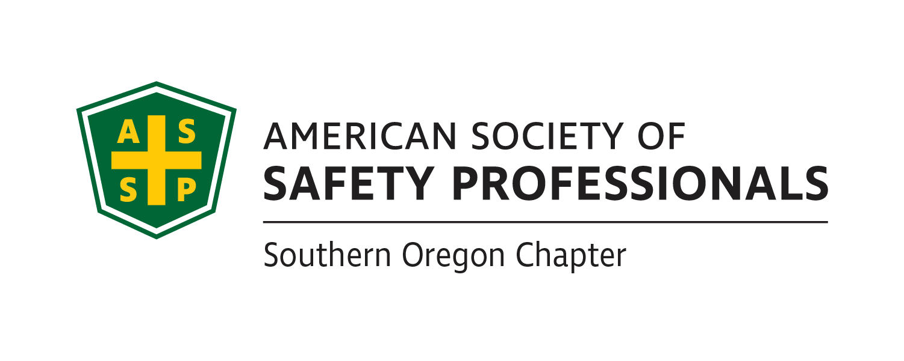
_______________________________________________________________________________________________________________________________________________________________________________________________________________________________________
Deadline: Applications must be received by August 30, 2019 at SAIF, Medford Office at 990 N. Phoenix Rd. Ste. 101, Medford, OR

Incomplete Applications will not be accepted

If you have questions or to arrange packet delivery:

Michael Hill michil@saif.com (541) 857-4229
David Hanson davhan@saif.com (541)-857-4236

Send your packets to:

ASSP – Southern Oregon Chapter
P.O. Box 1481
Medford, OR 97501-0110

