ASSP Award Nomination Form
2019 SOUTHERN OREGON
OCCUPATIONAL SAFETY & HEALTH CONFERENCE

Chapter - Safety Professional of the Year (SPY) Award .

Section 1 Submitter Information
Please share information about yourself, how you know the safety professional being nominated:
Company |  | Name
Address |  | Relation to Safety Professional Nominated
Phone |  | Your Title
Email |  |  | Fax

Section 2 Nominee Information
Please provide information about the safety professional that you are nominating for this award:

Company |  | Name
Address |  | Job Title
Phone |  | Areas of Responsibility  Within Company
Email

Please continue to second page for remaining requirements for nomination.

If you have questions or to arrange packet delivery:

Michael Hill michil@saif.com (541) 857-4229
David Hanson davhan@saif.com (541) 857-4236
Send your packets to:

ASSP – Southern Oregon Chapter
P.O. Box 1481
Medford, OR 97501-0110

Deadline: 2-Page application and written summary must be received by August 30, 2019 at SAIF, Medford Office at 990 N. Phoenix Rd. Ste. 101, Medford, OR

Incomplete Applications will not be accepted

Chapter - Safety Professional of the Year (SPY) Award .

Section 3 Application Checklist

Complete form Sections 1 & 2 by typing in each shaded field and printing

Attach type written summary describing specific accomplishments

Attach any supporting documentation that supports accomplishments

The Southern Oregon Chapter ASSP Safety Professional of the Year (SPY) Award acknowledges the dedication and outstanding contributions of an ASSP member to the safety and health of their employer organization or Chapter region. The nominee must be a member in good standing of the Chapter and Society, must not have won this award in the past five years and must work full time in the profession of protecting people, property and the environment.

Nominees will be judged on any of the following: Technical expertise in the broad field of safety; Demonstrated outstanding contributions to the Chapter, Region, Society, Practice Specialty, committee or task force; Professional contributions to advance the safety profession; Honors, awards, or citations received; Development of innovations, procedures or systems; Leadership in safety field and/or community; Improvement of programs and/or policies; Other personal achievements related to safety and health.

This award will be evaluated annually and presented on merit.

If chosen for award, a photo will be requested. Award winner will be recognized at the Southern Oregon Safety Conference and be nominated to receive the Regional SPY Award if qualifications are met.

Awards Committee Notes:________________________________________________________
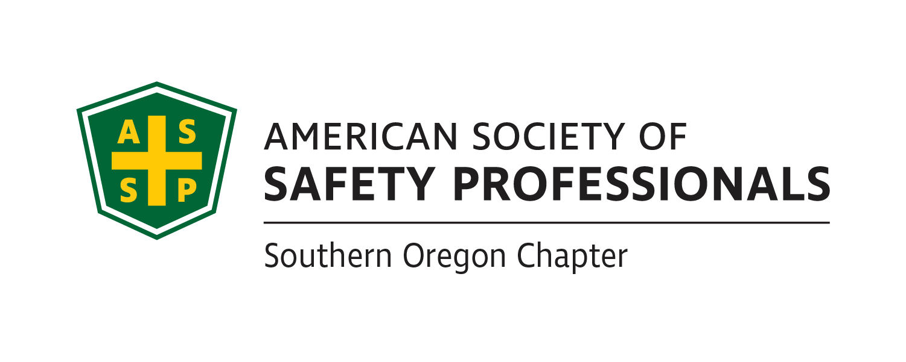
_______________________________________________________________________________________________________________________________________________________________________________________________________________________________________
Deadline: 2-Page applications and written summary must be received by August 30, 2019 at SAIF, Medford Office at 990 N. Phoenix Rd. Ste. 101, Medford, OR 97504

Incomplete Applications will not be accepted

If you have questions or to arrange packet delivery:

Michael Hill michil@saif.com (541) 857-4229
David Hanson davhan@saif.com (541) 857-4236

Send your packets to:

ASSP – Southern Oregon Chapter
P.O. Box 1481
Medford, OR 97501-0110

