ASSP Award Nomination Form
2018 SOUTHERN OREGON
OCCUPATIONAL SAFETY & HEALTH CONFERENCE

Business Leader Who Gets It Award .

Section 1 Submitter Information
Please share information about yourself, how you know the business leader being nominated:
Company |  | Name
Address |  | Relation to Business Leader Nominated
Phone |  | Your Title
Email |  |  | Fax

Section 2 Nominee Information
Please provide information about the business leader that you are nominating for this award:

Company |  | Name
Address |  | Job Title
Phone |  | Areas of Responsibility  Within Company
Email

If you have questions or to arrange packet delivery:

Michael Hill michil@saif.com (541) 857-4229
David Hanson davhan@saif.com (541)-857-4236
Send your packets to:

ASSP – Southern Oregon Chapter
P.O. Box 1481
Medford, OR 97501-0110

Deadline: Applications must be received by August 31, 2018 at SAIF, Medford Office at 990 N. Phoenix Rd. Ste. 101, Medford, OR 97504.

Incomplete Applications will not be accepted

Business Leader Who Gets It Award.

Section 3 Application Checklist

Complete form Sections 1 & 2 by typing in each shaded field and printing

Type written summary describing specific accomplishments

Attach any Supporting Documentation

The Business Leader Who Get’s It Award recognizes a business leader who has demonstrated an outstanding commitment to safety and health. This nomination will show how this leader has set the pace for safety in their organization going above and beyond the minimum requirements based on a core value to keep employees safe. This nomination should also explain the fruit of their efforts based on reduced injury rates, hazard elimination, and cultural elements that prove that the organization has benefitted from this leader’s efforts.

Written Summary (Or attach a separate page as needed):

Persons eligible for this award may not be a full time safety professional and must have a leadership role in their organization such as Principal, Manager, Controller, CEO, CFO, President or Owner:

This award will be evaluated annually and presented on merit.

If selected, a photo will be requested.

Awards Committee Notes:________________________________________________________
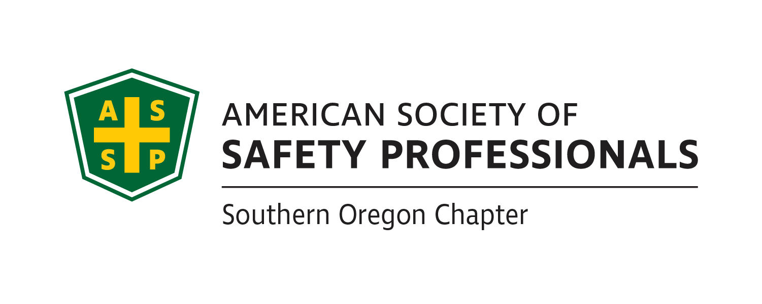
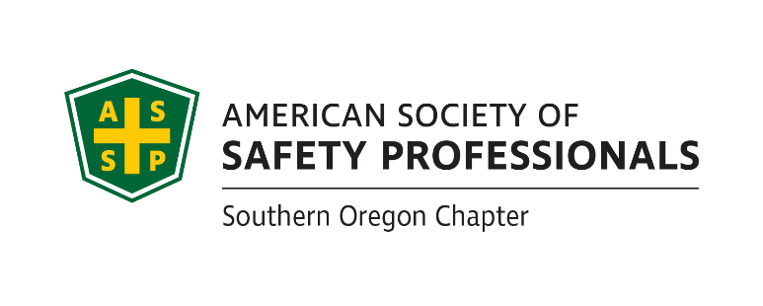
_______________________________________________________________________________________________________________________________________________________________________________________________________________________________________
Deadline: Applications must be received by August 31, 2018 at SAIF, Medford Office at 990 N. Phoenix Rd. Ste. 101, Medford, OR

Incomplete Applications will not be accepted

If you have questions or to arrange packet delivery:

Michael Hill michil@saif.com (541) 857-4229
David Hanson davhan@saif.com (541)-857-4236

Send your packets to:

ASSP – Southern Oregon Chapter
P.O. Box 1481
Medford, OR 97501-0110

