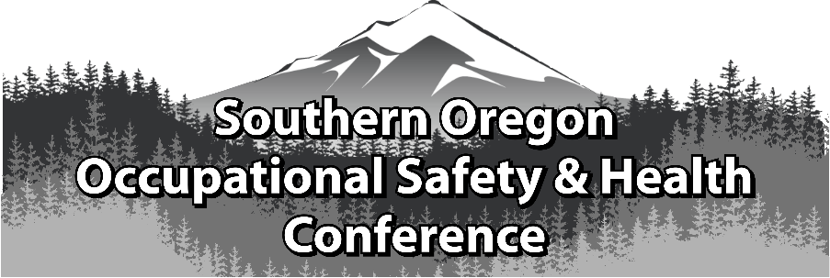
2018 SOUTHERN OREGON
OCCUPATIONAL SAFETY & HEALTH CONFERENCE
ASSP Award Application

Safety Committee Recognition Award
In Honor of ~ Frank J. Bertak

Best of the Best Safety Committee Award

Section 1 Company Information

Company |  | Contact Person
Address |  | Number of Employees
 |  | North American Industrial Classification System Code
Phone |  | To Look Up NAICS Code: https://www.naics.com/search/
Email |  |  | Fax

Section 2 Injury and Illness Statistics
Provide Injury and Illness statistics for each year:

Year | Total Number of Recordable | Number of regular and | Incident Rate:
 | Injuries & Illnesses on OSHA | overtime hours for all | Equals Number of Recordables
 | 300 A Summary | employees for the year | Times 200,000/Exposure hours
2017
2016
2015

Section 3 Application Checklist

Complete form Sections 1 & 2 by typing in each shaded field and printing

Type written summary describing specific accomplishments

Attach Supporting Documentation relevant to Safety Committee achievements and business including: Safety committee agenda, a list of current members, copies of safety committee minutes from past 12 months (July 1 to June 30) and quarterly inspection findings for this same period and other important achievements.
If you have questions or to arrange packet delivery:
Michael Hill michil@saif.com (541) 857-4229 or David Hanson davhan@saif.com (541)-857-4236

Deadline: Applications must be received by August 31, 2018 at SAIF, Medford Office at 990 N. Phoenix Rd. Ste. 101, Medford, OR 97504.

Incomplete Applications will not be accepted

Safety Committee Recognition Award

The Safety Committee Recognition Award identifies safety committees, its members and activities that have made a significant contribution towards the company’s overall success. Businesses of qualifying safety committees must not have experienced a fatality or catastrophic accident in the past twelve months prior to the award presentation.

Please submit a written summary of not more than one (1) type written page of safety committee accomplishments, and also include:

Example of the safety committee agenda
A list of current members
Copies of safety committee minutes from the past 12 months (July 1 to June 30)
Quarterly inspection findings from this same time period

Note: The safety committee minutes and inspection reports must meet the requirements of
OAR 437-001-0765 http://www.orosha.org/pdf/rules/division_1/437-001-0765.pdf

Best of the Best Safety Committee Award

One Safety Committee will be selected by the awards committee that demonstrates a superior safety committee effort during the award period. The Best of the Best Award will be given to the committee who outshines the rest in preventing injuries and illnesses, promoting the cause of safety and health and making safety fun and engaging for all employees.

If selected, a photo will be requested. Incomplete applications will not be accepted!

Awards Committee Notes:________________________________________________________
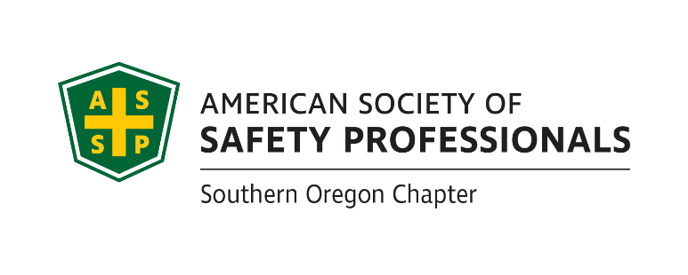
_____________________________________________________________________________________________________________________________________________________________________________________________________________________________________________________________________________________________________________________________________________________________________________________________________________________________________________________________________________________________________________________________________________________________________________________________________________________________________________________________________________________________________________________
If you have questions or to arrange packet delivery:
Michael Hill michil@saif.com (541) 857-4229 or David Hanson davhan@saif.com (541)-857-4236

Deadline: Applications must be received by August 31, 2018 at SAIF, Medford Office at 990 N. Phoenix Rd. Ste. 101, Medford, OR

Incomplete Applications will not be accepted

