2018 SOUTHERN OREGON
OCCUPATIONAL SAFETY & HEALTH CONFERENCE
ASSP Award Application

Outstanding Safety & Health Program Award
In Honor of ~ Randall M. Lundberg

Section 1 Company Information

Company |  | Contact Person
Address |  | Number of Employees
 |  | North American Industrial Classification System Code
Phone |  | To Look Up NAICS Code: https://www.naics.com/search/
Email |  |  | Fax

Section 2 Injury and Illness Statistics
Provide Injury and Illness statistics for each year:

Year | Total Number of Recordable | Number of regular and | Incident Rate:
 | Injuries & Illnesses on OSHA | overtime hours for all | Equals Number of Recordables
 | 300 A Summary | employees for the year | Times 200,000/Exposure hours
2017
2016
2015

Section 3 Application Checklist

Complete form Sections 1 & 2 by typing in each shaded field and printing

Type written summary describing specific accomplishments (See pg. 2 for topics)

Attach any Supporting Documentation relevant to an Outstanding Safety & Health Program.
If you have questions or to arrange packet delivery:

Michael Hill michil@saif.com (541) 857-4229
David Hanson davhan@saif.com (541)-857-4236

Send your packets to:

ASSP – Southern Oregon Chapter
P.O. Box 1481
Medford, OR 97501-0110

Deadline: Applications must be received by August 31, 2018 at SAIF, Medford Office at 990 N. Phoenix Rd. Ste. 101, Medford, OR 97504.

Incomplete Applications will not be accepted

Outstanding Safety & Health Program Award
In Honor of ~ Randall M. Lundberg

The Outstanding Safety & Health Program Award recognizes companies of all sizes that excel in addressing the seven major elements of an effective occupational safety and health program along with an effective safety committee.

The company must demonstrate the effectiveness of their activities by showing how the company has systematically controlled hazards to reduce the risk of injury to employees. The company must not have experienced a fatality or catastrophic accident in the past twelve months prior to the award presentation.

Please submit a summary from one (1) to three (3) type written pages explaining the accomplishments of your company in addressing the elements of your safety and health program and fill out the information on the reverse side of the form and submit it to the Awards Selection Committee. The summary will be evaluated on your explanation and examples of success in these areas:

● Management Commitment
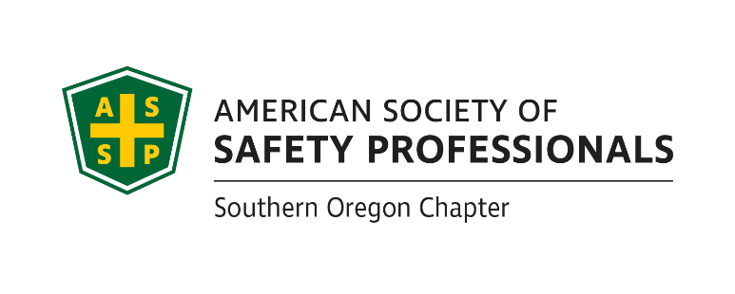
● Labor & Management Accountability
● Employee Involvement
● Hazard Identification and Effective Control
● Periodic Plan Evaluation
● Worker Training and Engagement
● Incident / Accident Reports, including root causes and recommendations
(Provide 3 of your most complete examples)
● Successful Safety Committee Activities

If selected, a photo will be requested. Incomplete applications will not be accepted!

Awards Committee Notes:________________________________________________________
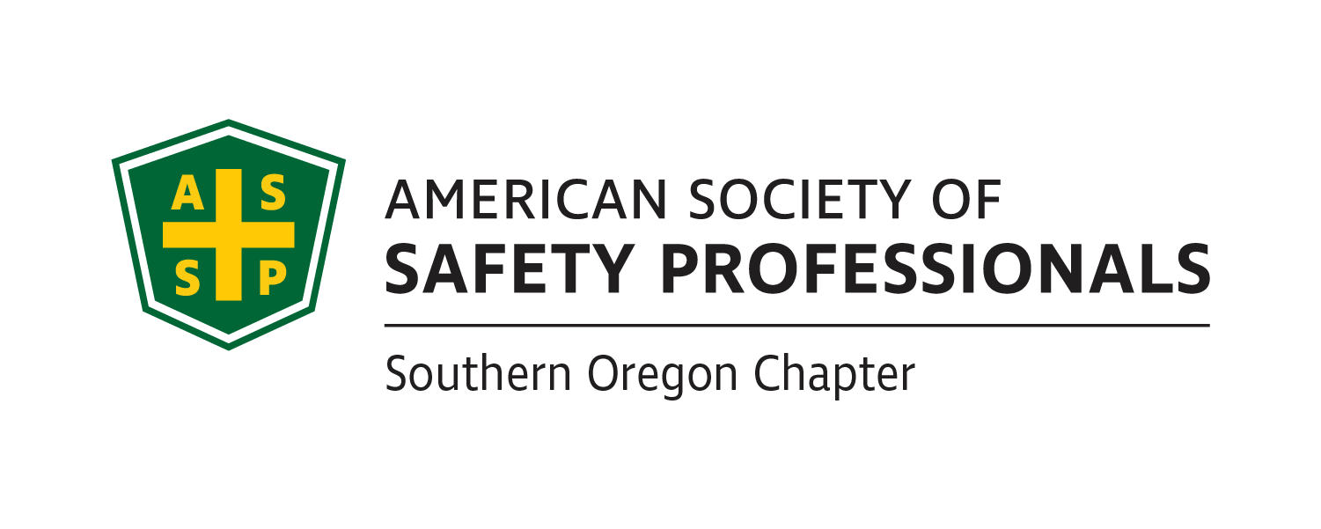
___________________________________________________________________________________________________________________________________________________________________________________________________________________________________________________________________________________________________________________________________________________________________________________________________________________________________________________________________________________________________________________________________________________________
Deadline: Applications must be received by August 31, 2018 at SAIF, Medford Office at 990 N. Phoenix Rd. Ste. 101, Medford, OR 97504.

Incomplete Applications will not be accepted

If you have questions or to arrange packet delivery:

Michael Hill michil@saif.com (541) 857-4229
Rusty Eccleston ecclesre@jacksoncounty.org (541)-774-6251

Send your packets to:

ASSP – Southern Oregon Chapter
P.O. Box 1481
Medford, OR 97501-0110

