

**2024 SOUTHERN OREGON**

**OCCUPATIONAL SAFETY & HEALTH CONFERENCE**

ASSP Award Application

***Outstanding Safety & Health Program Award***

**In Honor of ~ Randall M. Lundberg**

Section 1 Company Information

|  |  |  |  |  |  |
| --- | --- | --- | --- | --- | --- |
| Company |  | Contact Person | | |  |
| Address |  | Number of Employees | | |  |
|  | | North American Industrial Classification System Code | | |  |
| Phone |  | To Look Up NAICS Code: <https://www.naics.com/search/> | | | |
| Email |  | | Fax |  | |

Section 2 Injury and Illness Statistics

Provide Injury and Illness statistics for each year:

|  |  |  |  |
| --- | --- | --- | --- |
| Year | Total Number of Recordable | Number of regular and | Incident Rate: |
| Injuries & Illnesses on OSHA | overtime hours for all | Equals Number of Recordables |
| 300 A Summary | employees for the year | Times 200,000/Exposure hours |
| **2021** |  |  |  |
| **2022** |  |  |  |
| **2023** |  |  |  |

Section 3 Application Checklist

Complete form Sections 1 & 2 by typing in each shaded field and printing

Type written summary describing specific accomplishments (See pg. 2 for topics)

Attach any Supporting Documentation relevant to an Outstanding Safety & Health Program.

**If you have questions or to arrange packet delivery:**

Roy Harper [roy.harper@bbsi.com](mailto:roy.harper@bbsi.com) (541) 200-2199

Michael Hill [michil@saif.com](mailto:michil@saif.com) (541) 857-4229

David Hanson [davhan@saif.com](mailto:davhan@saif.com) (541) 857-4236

**Send your packets to:**

ASSP – Southern Oregon Chapter

P.O. Box 1481

Medford, OR 97501-0110

**Deadline:** Applications must be received by **August 30, 2024** at SAIF, Medford Office at 990 N. Phoenix Rd. Ste. 101, Medford, OR 97504.

**Incomplete Applications will not be accepted**

***Outstanding Safety & Health Program Award***

**In Honor of ~ Randall M. Lundberg**

**The Outstanding Safety & Health Program Award** recognizes companies of all sizes that excel in addressing seven major elements of an effective occupational safety and health program along with an effective safety committee.

**The company must demonstrate** the effectiveness of their activities by showing how the company has systematically controlled hazards to reduce the risk of injury to employees. The company must not have experienced a fatality or catastrophic accident in the past twelve months prior to the award presentation.

**Please submit a summary** from one (1) to three (3) type written pages explaining the accomplishments of your company in addressing the elements of your safety and health program and fill out the information on the reverse side of the form and submit it to the Awards Selection Committee. The summary will be evaluated on your explanation and examples of success in these areas:

● Management Commitment

● Labor & Management Accountabilit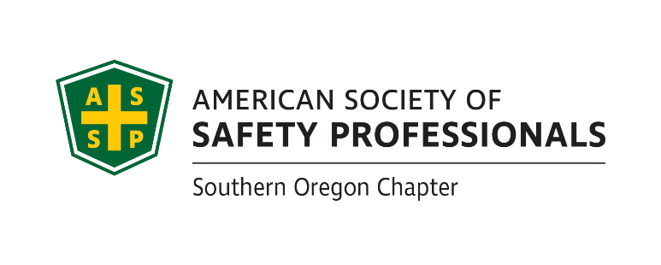y

● Employee Involvement

● Hazard Identification and Effective Control

● Periodic Plan Evaluation

● Worker Training and Engagement

● Incident / Accident Analysis, including root causes and recommendations

(Provide 3 of your most complete examples)

● Successful Safety Committee Activities

**If selected, a photo will be requested. Incomplete applications will not be accepted!**

*Awards Committee Notes:*________________________________________________________

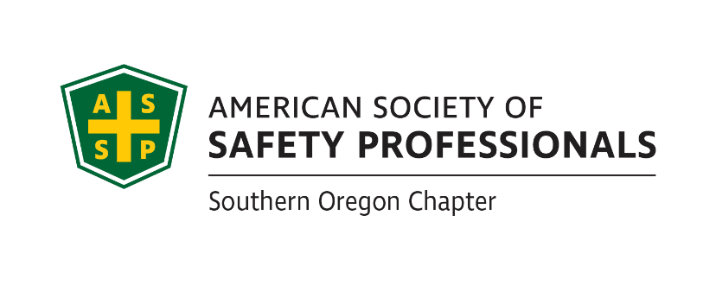___________________________________________________________________________________________________________________________________________________________________________________________________________________________________________________________________________________________________________________________________________________________________________________________________________________________________________________________________________________________________________________________________________________________

**If you have questions or to arrange packet delivery:**

Roy Harper [roy.harper@bbsi.com](mailto:roy.harper@bbsi.com) (541) 200-2199

Michael Hill [michil@saif.com](mailto:michil@saif.com) (541) 857-4229

David Hanson [davhan@saif.com](mailto:davhan@saif.com) (541) 857-4236

**Deadline:** Applications must be received by **August 30, 2024** at SAIF, Medford Office at 990 N. Phoenix Rd. Ste. 101, Medford, OR 97504.

**Incomplete Applications will not be accepted**

**Send your packets to:**

ASSP – Southern Oregon Chapter

P.O. Box 1481

Medford, OR 97501-0110